Guide for FPS Project:
Enemy Shooting the Player
This episode extends the enemy AI by giving enemies the ability to shoot the player when in the attacking state. The enemy will now spawn bullets, apply weapon bloom (inaccuracy), control fire rate, and display a muzzle flash when firing. This is covered in Episode 7 of the First Person Shooter in Unity 6 video series. At the end of this lab, you will push your work to GitHub so progress can be tracked over time.
Update the Enemy Script:
- Open the Enemy script and make the following changes:
  - Add new variables at the top of the file:
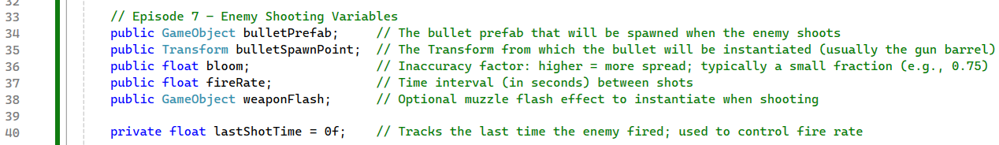
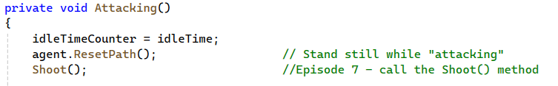
  - Locate the Attacking( ) state in the script and remove the comment placeholder inside the attacking logic and replace it with a call to the Shoot( ) method:
  - Add a new Shoot( ) method near the bottom of the Enemy script:
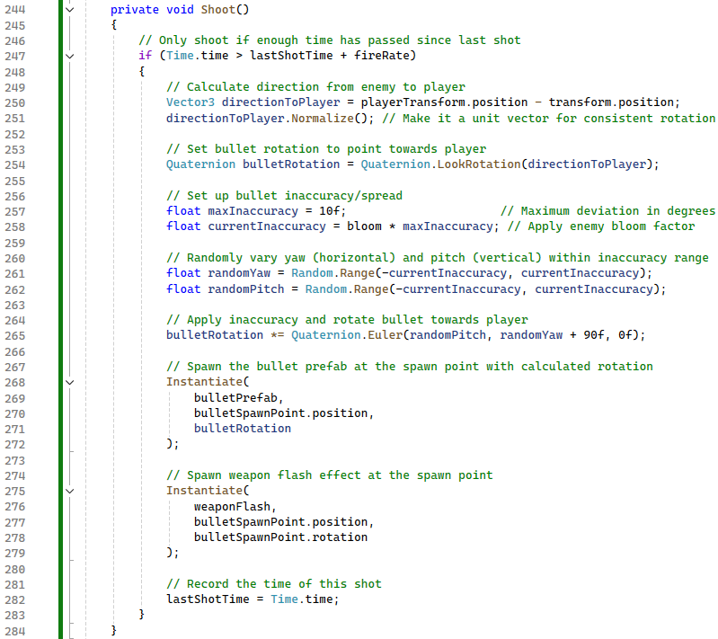
Enemy Setup in Unity:
- Return to Unity Editor.
- Select the Enemy GameObject.
- Scroll down to the Enemy script component and assign the following:
  - Bullet Prefab field Drag RifleBullet prefab from Assets
  - Bullet Spawn Point Expand the Enemy hierarchy Drag BulletSpawnPoint into the field
  - Weapon Flash Drag WeaponFlash prefab from Assets
  - Bloom = .75
  - Fire Rate = 0.5
(Enemy shoots once every half second)
Play Test:
- Verify the following behavior:
  - Enemy chases the player when detected
  - Enemy stops and shoots when close enough
  - Bullets spawn from the weapon
  - Weapon flash appears when shooting
  - Enemy does not shoot continuously (fire rate works)
Push to GitHub:
- Save Your Work:
  - File → Save in Unity
- Open GitBash:
  - Navigate to your project folder.
  - Ensure you are on main branch.
  - Stage changes:
$ git add .
  - Commit:
$ git commit -m "Episode 7 completed: Enemy shooting with bloom & fire rate"
  - Push:
$ git push origin main

